Azure Reservations
Purchase Azure services for 1 or 3 years in advance with a significant discount
- Reserved instances – Azure Virtual Machines
- Reserved capacity – Azure Storage, SQL Database vCores, Databricks DBUs, Cosmos DB RUs
- Software plans – Red Hat, Red Hat OpenShift, SUSE Linux, etc.
- Reservations are made for 1 or 3 years
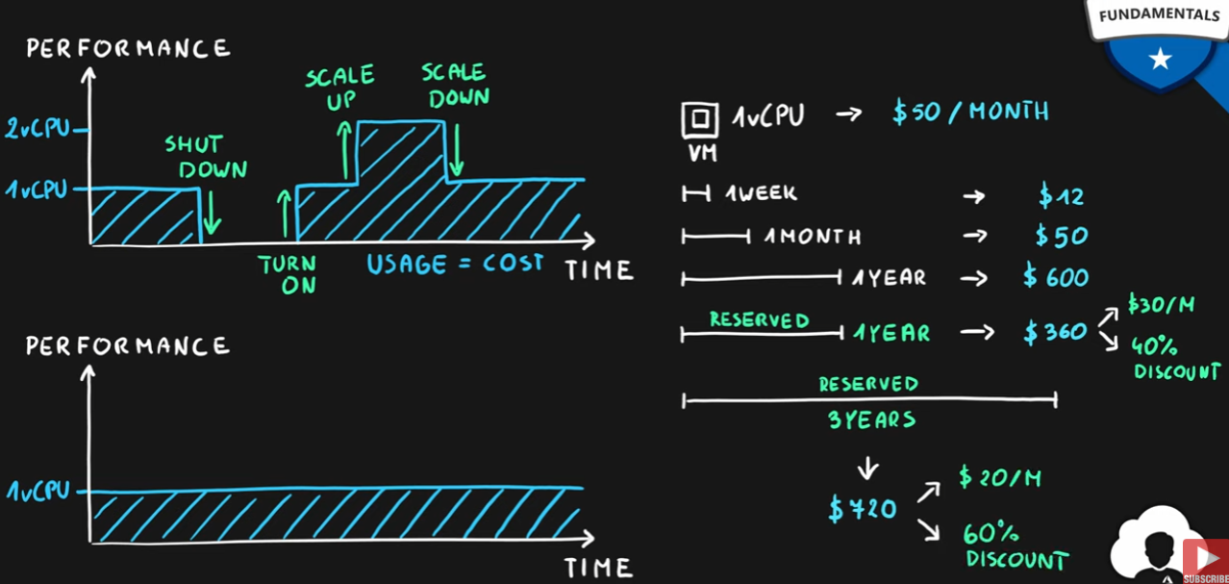

Azure Spot VMs
Purchase unused Virtual Machine capacity for significant discount
- How it works
  - Significant dicount for Azure VMs
  - Capacity can be taken away at any time
  - Customer can set maximum price after discount to keep or evict the machine
- Best for interruptable workloads (batch processing, dev/test environments, large compute workloads, non-critical tasks, etc.)
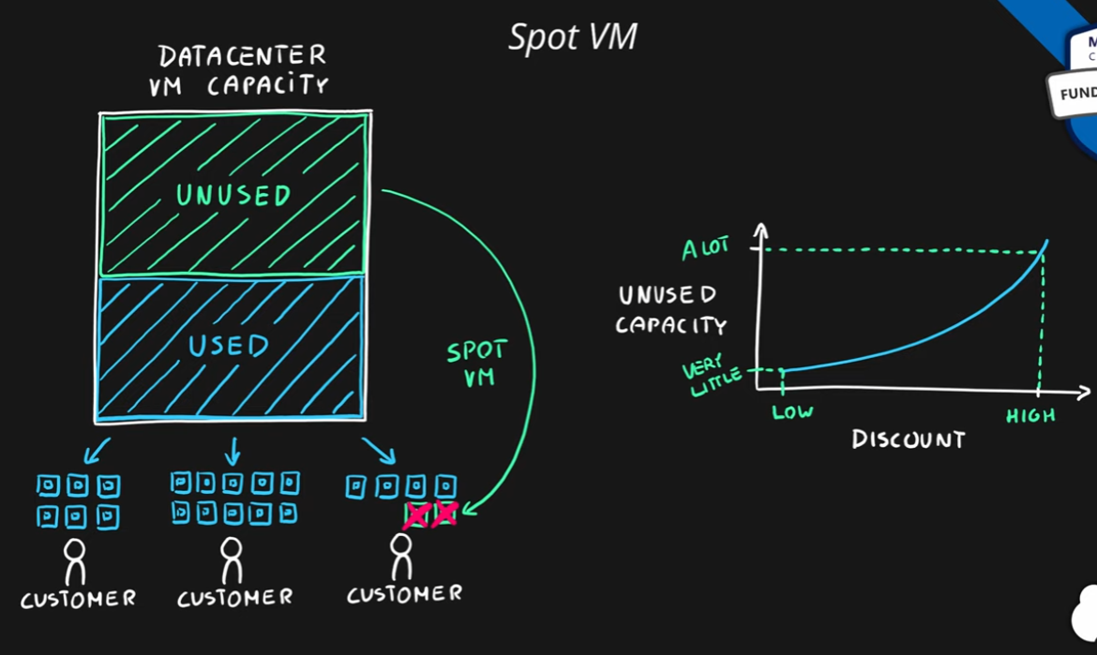
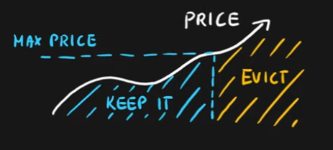

Hybrid use Benefit
Use existing licenses in the cloud
- Use existing licenses in the Azure
  - Windows Server
    - Azure VM
  - RedHat
    - Azure VM
  - SUSE Linux
    - Azure VM
  - SQL Server
    - Azure SQL Database
    - Azure SQL Managed Instance
    - Azure SQL Server on VM
    - Azure Data Factory SQL Server Integration Services
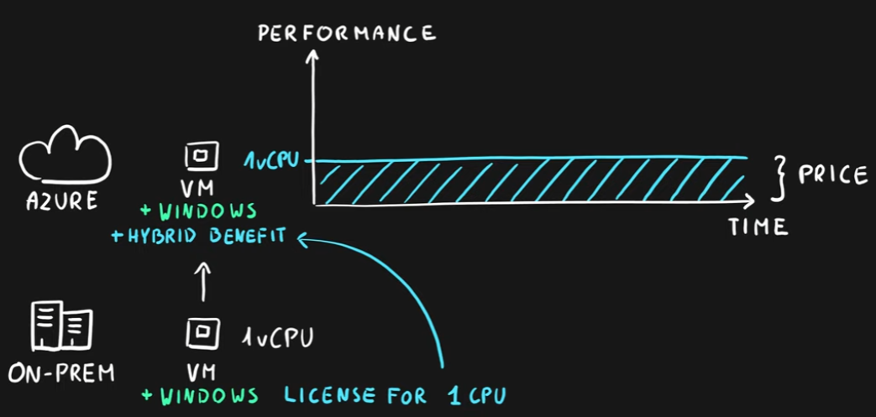

Tools
- Pricing calculator – estimate the cost of Azure services
  - Select service
  - Adjust parameters (usage)
  - View the price
- Total Cost of Ownership (TCO) calculator – estimate and compare the cost of running workloads in datacenter versus Azure
  - Define your workloads
  - Adjust assumptions
  - View the report
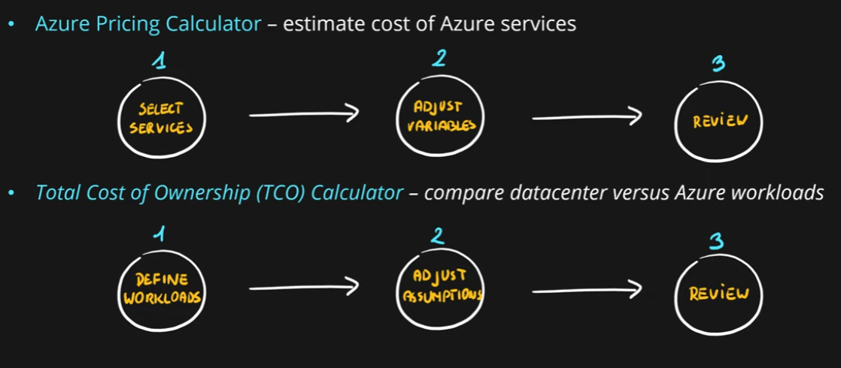
Summary
